Project Profile

Things Achieved:

As I was busy on working with the implementation of the WiFly wireless interface concerning the lab 8, I was unable to implement the interfacing of the magnetometer and the accelerometer concerned with the project. I will start working on that part in the current lab session beginning on Friday and hoping to get done with it over the weekend.  
In the meanwhile, I have continued my research on the interfacing of the GPS receiver with the STM32 board. In order to calculate the distances over sloping terrain the tilt angle will be calculated by the magnetometer and this can be implemented to record the actual distance covered instead of the perceived readings reported by the GPS receiver.

Additionally I have been going through some papers to understand the relation between one’s height and the length of the stride. However, the discussions on that part are not conclusive. Hence, during the testing part of the application the readings will be analyzed to come up with a successful approximation on a trial and error basis.

Also, I have decided on the design of the web application for displaying the visualization of the logged GPS, magnetometer and the accelerometer data. I would like the web application to have a simple interface where the user can chose the visualization or the statistics he wants to view. There will not be any log in id and password associated with the user. Since the future scope illustrates that the application is supposed to be fitted onto the shoes, there should not be a scenario in which more than one user uses the step counter at a time.

Plans for the current week:

Starting on Friday. The interfacing of the magnetometer and accelerometer with the STM32 board will be started. Along with this the SD card will be interfaced the board to check if the values reported by the magnetometer and the accelerometer are successfully logged into the SD card. Also, the design prototype for the web application should be ready by the next lab.

Updated Milestone

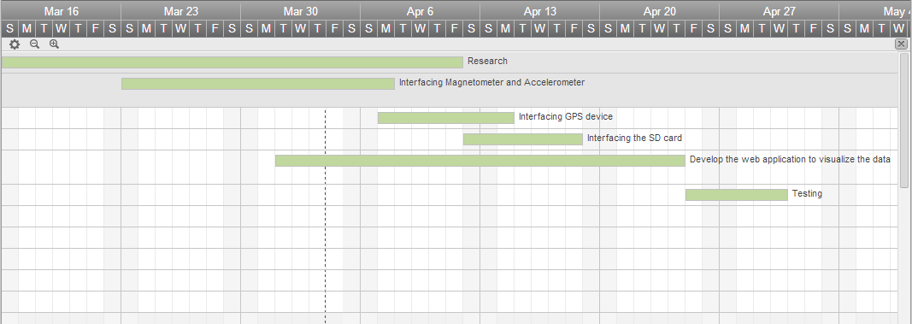

Block Diagram (with Magnetometer)

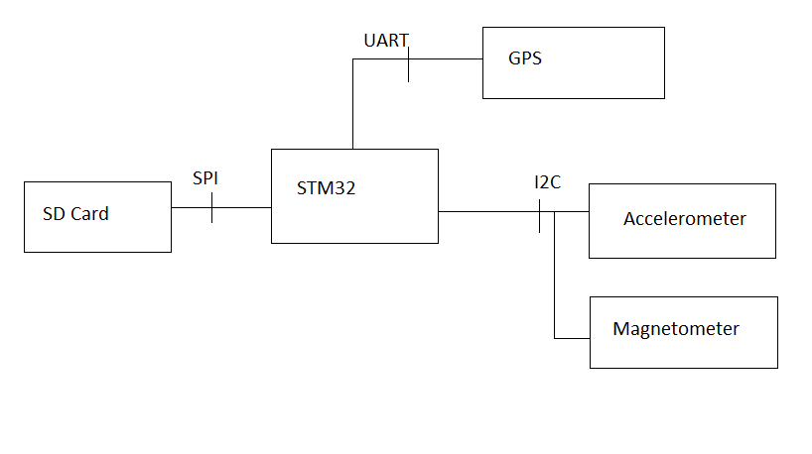

Resources:  
 <http://shukra.cedt.iisc.ernet.in/edwiki/Interfacing_of_GPS_module_with_STM32L_Discovery_Board>  
<http://www.usc.edu/CSSF/History/2008/Projects/J1304.pdf>  
http://digitalcommons.wku.edu/cgi/viewcontent.cgi?article=1321&context=ijes